**Analysis of Factors Causing Infant Motility and Decline in Karnataka**

Dr.P.G. Sunitha Hiremath, Ananya Deshpande, Nirmala Kanti, Kavya Handigund, Namrata Kanamadi, Hubli Karnataka.

**I. ABSTRACT**

This study aim is to analyze the factors that causes infant death in Karnataka and understand the distribution of leading causes of infant death, compare the infant death rates, and assess the distribution of vaccines among infants in all districts of Karnataka. We analyzed the trends in infant death rate from 2017-18 to 2019-20. It is a Heath Management System that describe both Maternal and Infant health and death causes district wise in Karnataka. Infant data were extracted and analyzed by grouping the district into 4 administrative divisions. From the given data we observed that infant death have reduced by 0.1% from 2017-18 t0 2019-20 But there are district like and Gulbarga and Bellary where there has been increased in infant death by 0.57%and 0.533% respectively. In all over 3 years Bangalore Urban recorded the highest number of deaths. With this, we get information about major districts that have the highest infant death rate and this will help us to give more medical facilities to those places for reducing the infant death rate. The factor causing infant deaths include Asphyxia(45% ), Sepsis(30%), and Pneumonia(18%) in all 3 years. While a decline in mortality rates was observed in Hassan, Bangalore Urban. Interestingly these district also showed a reduction in Sepsis. Based on this analysis ,it can b conclude that addressing the treatment of asphyxia and reducing the prevalence of sepsis and Pneumonia are the crucial steps towards the achieving the infant mortality rate in Karnataka.

**Keywords:** Infant Deaths ,Asphyia, Sepsis, Pneumonia complications.

# Introduction

As per the survey of the Karnataka gov- ernment around 9Lakhs deliveries would take place every year and it is decreasing over the years. Teenage marriage is also one reason for infant death because of improper growth of the uterus. The report National Family Health Sur- vey (NFHS)-5 conducted in the year 2019-20 states that in Karnataka 5.4% of young women in the age group 15-19 are already pregnant and the number has reduced over the years. As per Dr Hemavathi, better health maintenance prevents infant death and early recognition of abnormali-

*∗*Corresponding author.

*Email address:* [pgshiremath@kletech.ac.in](mailto:pgshiremath@kletech.ac.in) (P G Sunitha Hiremath)

ties will help to improve child health facilities and prevent infant deaths.

Generally, infant death rate is expressed as the number of deaths per 1000 live births in a given period. Infant death rate is a key factor for de- termining the overall health of infants and refers to the number of infants died per 1000 live births. IMR is calculated as

IMR=(ID/LB) *1000

ID: Number of infant deaths LB: Number of live births

The infant death rate is influenced by the socio-economic conditions of the family, access to health care, proper nutrition, maternal health, and prevention of diseases and infections. It re- flects the availability of health facilities in the system. The reasons for infant death rate can

vary. Karnataka is one of the prominent states in India and ranks in the higher position for in- fant death rate which was 25 in 2017-18. Kar- nataka is mainly divided into four administrative divisions namely Bangalore, Belgaum, Mysore, and Kalburgi division. Bangalore Urban, Ko- lar, Chikkaballapur, Shivamoga, Tumkuru, Ban- galore Rural, Chitradurga, and Davanagere dis- tricts comes under the Bangalore division. Be- lagum division consists of Bagalkot, Belgaum, Vi- jayapura, Dharwad, Gadag, Haveri, and Uttara Kannada. Kalburgi division consists of Gulbarga, Bellary, Koppal, Yadgir, and Raichur. Mysore di- vision consists of Mysore, Chamarajnagar, Chik- magalur, Dakshina Kannada, Hassan, Kodagu, Mandya, and Udupi. Karnataka government has held programs to create awareness about infant and maternal health such as the Reproductive and Child Package of the National Family Wel- fare program, Child Survival, and safe mother- hood programs. These programs mainly involve the prevention of unwanted pregnancy, antenatal care, child survival, and management of reproduc- tive and sexually transmitted diseases [1]. Overall, in India, infant death rate is declined by 2.9% in 2017 and 3.1% in 2018 [2]. In the last ten years, IMR in India has witnessed a decline of about 36% from 44 to 28. The corresponding decline in rural areas is from 48 to 31, and for urban ar- eas from 29 to 19, thereby exhibiting about 34% decline respectively. Despite the decline in IMR over the last decades, one in every 36 infants dies within the first year of their life at a national level. The current infant death rate of India in 2023 is 26.619 deaths per 1000 live births, a 3.89% decline

from 2022.

# LITERATURE SURVEY

As per WHO, the leading causes of death in children under-5 years are preterm birth compli- cations, pneumonia, birth asphyxia, diarrhoea, and malaria. Nearly half of these deaths are in newborns, a figure that will rise as the mortality rate for older infants continues to fall [3]. The au- thors have explored causes for infant death and found that about 15 percent of neonatal deaths

are caused due to Asphyxia and Sepsis is found to be the second major cause of neonatal deaths in India [4]. As per the research done by the author on the data available by D H O office of Shivamogga to analyze the causes for infant death, he concluded that in India over 4Lakh new born infants die in their first 24 hours and 90% of infants are died due to diseases like asphyxia, sepsis, and pneumonia [5]. Author states that a range of neonatal mortality assessed for infants in 2014-15, the most common neonatal compli- cations include breathing difficulties and feeding problems [6]. Across the world every year, 2.8 mil- lion infant deaths are reported within the com- pletion of a month due to complications during birth [7]. An author’s study states that infant mor- tality in India in 2014-18 is 24.5 per 1000 and lead- ing causes for this is prematurity (27.9%),birth asphyxia and infections (23.7%) and congenital anomalies (18.4%) [8]*.* Other factors for increased risks of neonatal mortality included low levels of maternal education, high and low parity, and fewer ANC visits. In urban areas, the neonatal mortality rate is eight, whereas this number more than doubles in rural areas (18). But compared to other states, rural Karnataka has the highest proportion of neonatal deaths, out of total infant deaths [9].

# METHODOLOGY Data collection

We collected data from Health Management System from the Karnataka Government’s offi- cial website https://data.gov.in, named as Per- formance Key Indicators which contains 3 year in- formation of about maternal health, infant health, and medications suggested to improve health sta- tus. To carry out our work, we selected the data related to infants and grouped the data into 4 ad- ministrative divisions of Karnataka. This dataset allows for an in-depth analysis of various factors related to infant health in Karnataka.

# Data Pre-processing Data Cleaning

The missing value in the raw data set must be eliminated. A total of 0.35% of values were found

were found missing in a complete dataset of size 17460 (i.e. 61). The dataset only consists of numerical data values hence, replaced these missing values with mean.

**Data Integration**

We collected the dataset related to health and management systems from the website <https://data.gov.in>. For the analysis, we merged 3 years data into a single dataset by adding an attribute year. The final dataset consists of 90 rows and 31 columns.

# STATISTICAL ANALYSIS

Data Analysis refers to making informative visualizations as part of an exploratory process. A set of questionnaire are formed for analysing the dataset on different attributes and an inference is given to the plots making it useful for further decisions. We arrived at the questions that can be analysed through our data and we drill down the question to obtain a more effective analysis. A total of 32,904 infant deaths were reported in Karnataka from 2017-18 to 2019-20. Infant death rate decreased from 12024 in 2017-18 to 10211 in 2019-20 due to an increase in health facilities and proper nourishment to children during its fatal stage.

From Table 1 we observed that in the year 2017-18 the number of deliveries are less than the number of live births since one delivery may result in twins or triplets. The number of infant deaths has decreased one per 1000 every year.

Fig.1 illustrates the variations in infant death rate across different divisions of Karnataka, including Bangalore, Belgaum, Kalburgi, and Mysore. Notably, the Kalburgi division experienced higher infant death rate rates in both 2017-18 and 2019-20 in comparison to other divisions. However, there has been a positive trend as it decreased by 0.079% in the next years. Bangalore and Mysore divisions showed relatively the same infant death rate rates over the years. Although the Bangalore division had lower infant death rate than Kalburgi, it is concerning that certain districts within the Bangalore division have higher death rates. Specifically, Bangalore Urban stands out as the district with the highest infant death rate across all 3 years. Additionally, Bangalore Rural also reported high rates in 2017-18 and 2019-20, while Ramanagar had the lowest rate in 2019-20. These disparities indicate that despite the Bangalore division's overall lower infant death rate as compared to Kalburgi, there are high infant death rate districts within the division itself. It is crucial to address the specific issues faced by districts like Bangalore Urban and Bangalore Rural and Ramanagar to make further progress in reducing infant deaths in the region. While Kalburgi division has shown improvement in recent years, the attention should now be shifted to tackle the challenges within Bangalore division.

From Table 2, we get information about the number of infant deaths occur due to different diseases in Karnataka from 2017-18 to 2019-20.

**Leading Causes for Infant Death**

The figure infers that the majority of infants died due to the Asphyxia i.e. 45% of infants died due to asphyxia from 2017-18 to 2019-20. Asphyxia is a respiratory problem caused due to severe lack of oxygen in the human body. We infer that Asphyxia is a major cause of infant death in all 3 years. Sepsis and Pneumonia are the other major reasons for infant death.

The figure 3 indicates that Kalburgi division has a higher infant death rate due to asphyxia compared to other divisions. This is mainly attributed to increased death rate in Bidar, Bellary, and Gulbarga districts. However, there is a positive trend with a 9.15% decline in asphyxia-related infant deaths from 2017-18 to 2019-20. This improvement is likely due to better health facilities and treatment availability. Infant death is increasing over years in Mysore division at the rate of 3.15% and in 2019-20, Bijapur recorded the highest number of infant deaths due to asphyxia, accounting for around 3.05% of all reported infant deaths It is essential to investigate and address the reasons behind this increase as the death rate in Bijapur was lower in previous years. Overall, Karnataka has seen progress, with a decrease from 5388

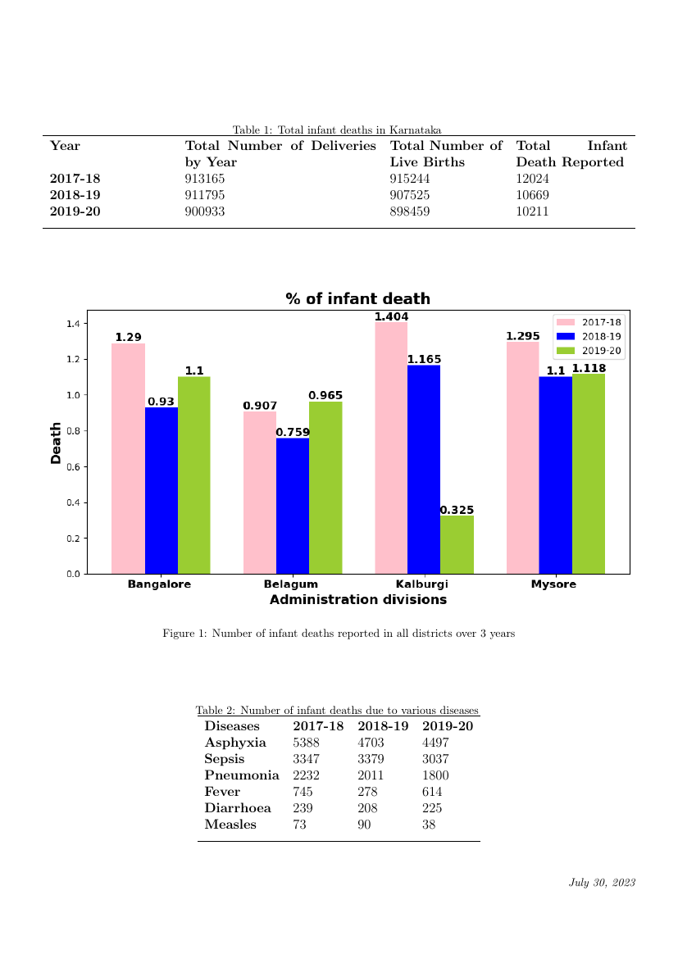

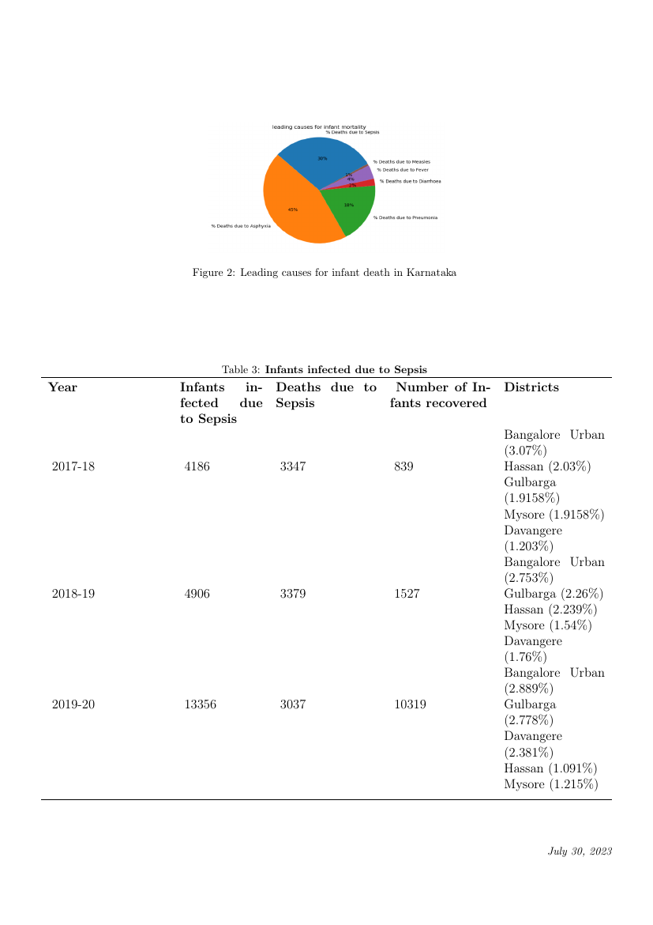

reported asphyxia-related infant deaths in 2017-18 to 4497 in 2019-20. Continued efforts are crucial to sustain and further reduce infant deaths in the Karnataka.

**Infant deaths reported due to Sepsis in all districts of Karnataka**

Fig.4 Variation of Sepsis across divisions of Karnataka

Figure 4 reveals a concerning trend of increasing infant deaths due to sepsis in Kalburgi district over the years, with a notable exponential surge in 2019-20. This indicates a worrisome rise at a rate of 4.45% from 2017-18 to 2019-20. The significant increase in sepsis-related deaths in Gulbarga, Bellary, and Koppal districts, at rates of 3.5%, 7.2%, and 5.7% respectively, has contributed to this concerning pattern within Kalburgi division. In the Bangalore division, there is also a noticeable increase in infant deaths due to sepsis, rising by 1.3% over the analyzed period. Among all districts of Karnataka, Bangalore Urban stands out with the highest number of infant deaths due to sepsis in all three years. On a positive note, Belgaum division exhibits a different trend, with a decrease in sepsis-related infant deaths over the years. This improvement indicates that efforts made in Belgaum division have been effective in reducing infant death rate due to sepsis. It is evident from the data that there is a need to address the factors contributing to the increasing sepsis-related deaths in Kalburgi division, especially in the districts of Gulbarga, Bellary, and Koppal. Improved healthcare facilities are essential to reverse this concerning trend and protect the lives of infants in these regions.

**Infant deaths were reported due to Pneumonia in all districts of Karnataka**

Table 5: Infant death due to Pneumonia with major districts

**Infant Immunisation Programs**

* **N Rotavirus vaccine**

From table 6 Rotavirus vaccination is given to the infant to prevent them from getting infected with Diarrhoea (caused by rotavirus) and dehydration. The number of infants that have received Rotavirus Vaccination has increased from year to year. But substantially the intake of the 2nd & 3rd doses has been decreased compared to the 1st dose. It shows the increase in awareness about vaccination which may help to reduce infants death and the number of infected infants in Karnataka.

* **DPT Vaccination**

Table 7 indicating the Variation of DPT1, DPT2, DPT3 Vaccination in different divisions of Karnataka. DPT refers to Diphtheria (Bacterial infection), Pertussis (Whooping cough), and Tetanus. This vaccine is given to protect infants from getting infected. Diphtheria is a bacterial infection it mainly affects the respiratory tract (nose, throat). It can lead to difficulty in breathing and severe heart problems which in turn might lead to death.Pertussis is a contagious respiratory disease c aused by bacteria and results in whooping cough. Tetanus is a bacterial disease that affects the nervous system and it enters the body through wounds. The number of infants affected by DPT is very less over 3 years i.e. 275 due to diphtheria, 41 infants affected due to pertussis, and 15 are affected by tetanus. From table 7, we observe that 6934 infants received the DPT1 in 2017-18 but it decreased by 3685 in 2018-19 and it slightly increased in 2019-20(by 939). In 2017-18 total of 4419 infants received the DPT2 but it decreased by 2649 in 2018-19 and it slightly increased in 2019-20 (by 198). In 2017-18 total of 5053 infants received the DPT3 but it decreased by 2824 in 2018-19 and it slightly increased in 2019-20 (by 190). DPT is more distributed in Yadgiri in all 3 years for all doses of DPT and least in Raichur. From this, we observe that there is not much variation in the vaccination distribution.

**BCG (**Bacille Calmette-Guerin**) vaccine**

BCG vaccine is generally given to protect infants from TuberCulosis. It mainly affects the respiratory tract, so it can lead to difficulty in breathing. From fig.9 number of infants affected due to TB increased from 1358 to 1668 in 2017-18 and 2019-20 respectively. In 2017-18 total of 10,49,034 infants received the BCG vaccine, 10,41,430 in 2018-19, and 10,20,798 in 2019-20. From this observation, the number of infants who received BCG decreased from 2017-18 to 2019-20.

Table 5, provides data on the total number of infants affected by pneumonia, deaths, and recoveries over the years. The death rate decreased over the years, but the number of infected infants increased from 17,790 to 38,611. The infant death rate per 1000 affected infants declined from 125 in 2017-18 to 87 in 2018-19 and further to 47 in 2019-20. In 2017-18, Kodagu had the highest percentage of infant deaths (15.6%), which decreased to 2.3% in 2018-19 and 8.7% in 2019-20. In 2018-19, Chikkamagalur had the highest percentage of infant deaths (17.1%), which decreased to 6.3% in 2017-18 and 9.6% in 2019-20. Finally, in 2019-20, Hassan had the highest percentage of infant deaths (11.5%).from figure 5 there is a variation of infant death across all the division of Karnataka. The data emphasizes the need for targeted efforts to address the high infant death rate due to pneumonia in Mysore division and specific districts. Here there is a variation of infant death across all the division of Karnataka. The data emphasizes the need for targeted efforts to address the high infant mortality due to pneumonia in Mysore division and specific districts.

Table 5: Infant death due to Pneumonia with major districts

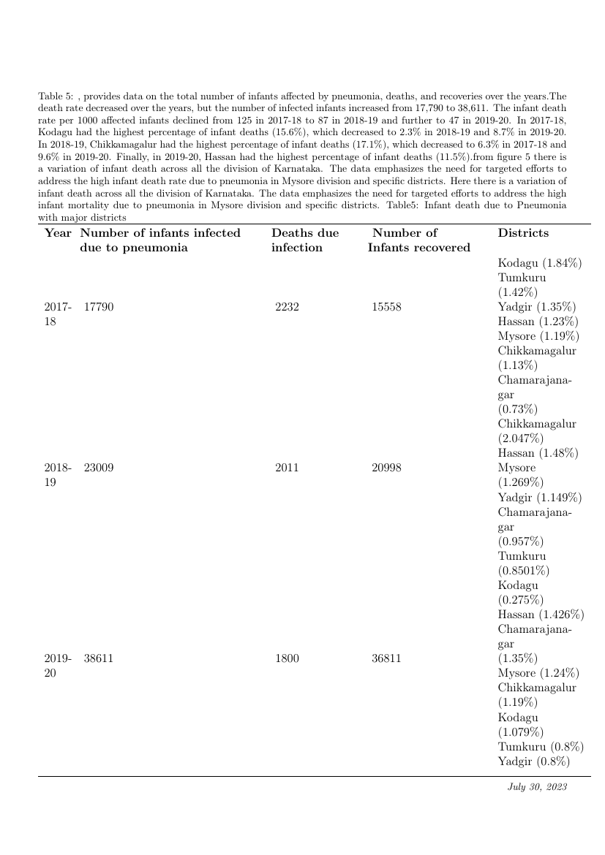

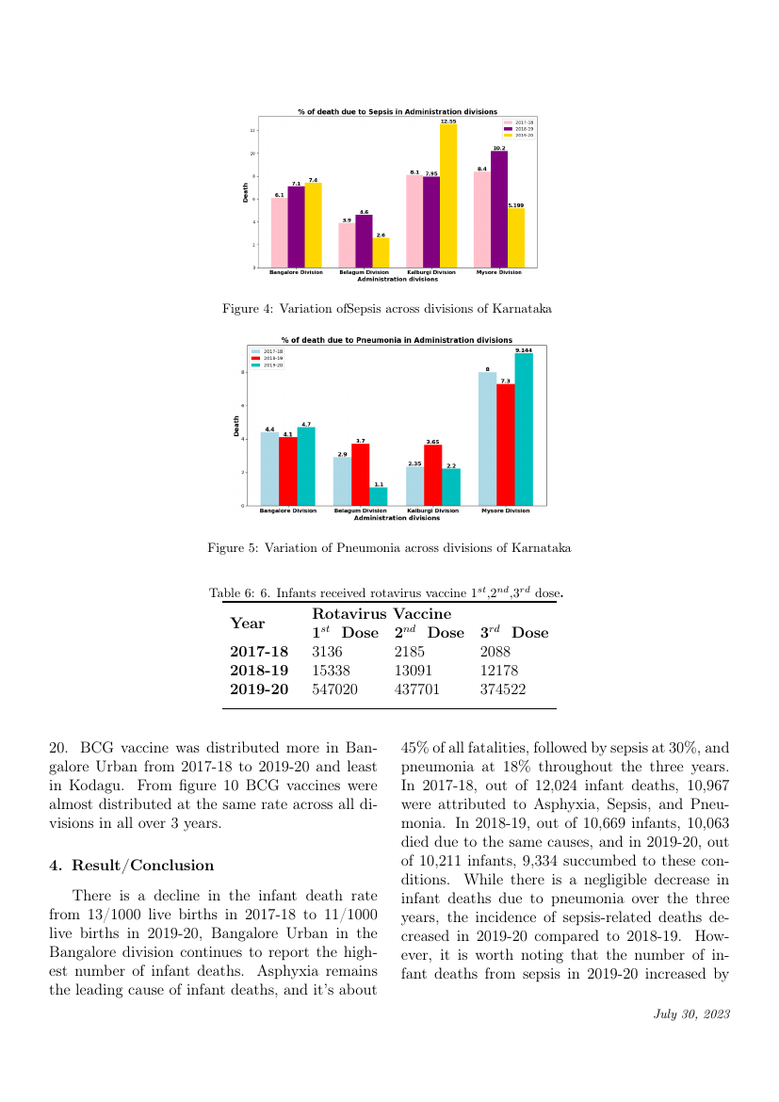

and least in Kodagu. From figure 10 BCG vaccines were almost distributed at the same rate across all divisions in all over 3 years.

**Result/Conclusion**

There is a decline in the infant death rate from 13/1000 live births in 2017-18 to 11/1000 live births in 2019-20, Bangalore Urban in the Bangalore division continues to report the highest number of infant deaths. Asphyxia remains the leading cause of infant deaths, and it’s about 45% of all fatalities, followed by sepsis at 30%, and pneumonia at 18% throughout the three years. In 2017-18, out of 12,024 infant deaths, 10,967 were attributed to Asphyxia, Sepsis, and Pneumonia. In 2018-19, out of 10,669 infants, 10,063 died due to the same causes, and in 2019-20, out of 10,211 infants, 9,334 succumbed to these conditions. While there is a negligible decrease in infant deaths due to pneumonia over the three years, the incidence of sepsis-related deaths decreased in 2019-20 compared to 2018-19. However, it is worth noting that the number of infant deaths from sepsis in 2019-20 increased by 1.91% compared to the figures recorded in 2017-18. Overpopulation, lack of awareness about maternal and infant health, and socio-economic disparities are contributing factors to these challenges. So we need to take various strategies, measures, and health facilities to reduce infant death and improve the mother's health Improvement in healthcare infrastructure, encouraging antenatal care and family planning, and focusing on preventable causes like infections, birth complications, and immunization drives can affect reducing the 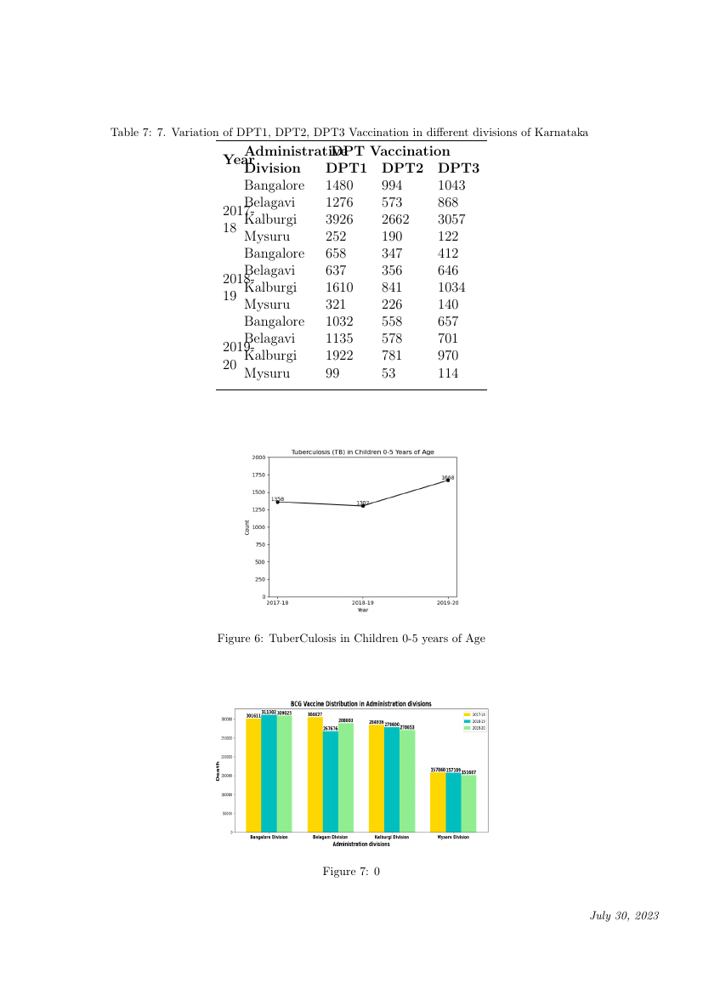infant death rate.

Figure 7: BCG vaccine Distribution in administrative divisions

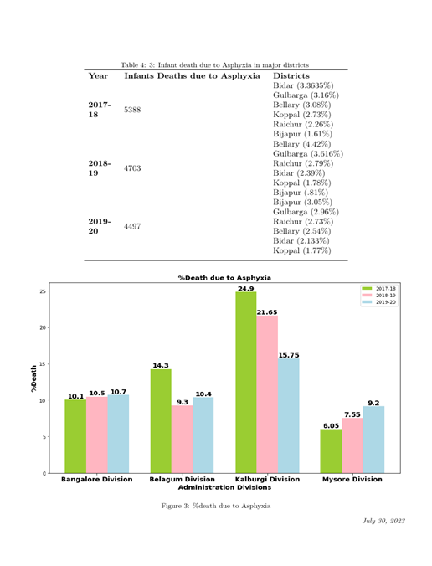

VI. REFERENCES

[1]. Dhaded SM, Somannavar MS, Moore JL, McClure EM, Vernekar SS, Yogeshkumar S, Kavi A, Ramadurg UY, Nolen TL, Goldenberg RL, Derman RJ, Goudar SS. Neonatal deaths in rural Karnataka, India 2014-2018: a prospective population-based observational study in a low-resource setting. Reprod Health. 2020 Nov 30;17(Suppl 2):161. doi: 10.1186/s12978-020-01014-6. PMID: 33256777; PMCID: PMC7708103.

[2]. Singh A, Pathak PK, Chauhan RK, Pan W. Infant and child mortality in India in the last two decades: a geospatial analysis. PLoS One. 2011;6(11):e26856. doi: 10.1371/journal.pone.0026856. Epub 2011 Nov 2. PMID: 22073208; PMCID: PMC3206872.

[3]. Pauses and reversals of infant mortality decline in India in 2017 and 2018.Jean Dreze Aashish Gupta Sai Ankit Parashar Kanika Sharma

[4]. Singh M, Paul VK. Maternal and child health services in India with special focus on perinatal services. J Perinatol. 1997 Jan-Feb;17(1):65-9. PMID: 9069069.

[5]. Jana A, Saha UR, Reshmi RS, Muhammad T. Relationship between low birth weight and infant mortality: evidence from National Family Health Survey 2019-21, India. Arch Public Health. 2023 Feb 21;81(1):28. doi: 10.1186/s13690-023-01037-y. PMID: 36803539; PMCID: PMC9942291.

[6]. Bruce SG, Blanchard AK, Gurav K, Roy A, Jayanna K, Mohan HL, Ramesh BM, Blanchard JF, Moses S,Avery L. Preferences for infant delivery site among pregnant women and new mothers in Northern Karnataka, India. BMC Pregnancy Childbirth. 2015 Feb 27;15:49. doi: 10.1186/s12884 015-0481-8. PMID: 25884166; PMCID: PMC4345019.

[7]. https://platform.who.int/data/maternal-newborn- child-adolescent-ageing/child-data/child---mortality-causes-of-death

[8]. A Study on Infant Mortality in Karnataka (With Special Reference to Shimoga district) RASHMI R.K.*1 , RAMESH, B.2 AND S. KUMAR3 2Registrar and 3Assistant Professor 1Department of Social Work, Kuvempu University, Shankargatta (Karnataka) India 2KSOU Mysore University, Mysore (Karnataka) India 3Vijayanagarasri Krishnadevaraya University, Bellary (Karnataka) India

[9]. Bellad MB, Vidler M, Honnungar NV, Mallapur A, Ramadurg U, Charanthimath U, Katageri G, Bannale S, Kavi A, Karadiguddi C, Sharma S, Lee T, Li J, Payne B, Magee L, von Dadelszen P, Derman R, Goudar SS; CLIP Working Group. Maternal and Newborn Health in Karnataka State, India: The Community Level Interventions for Pre-Eclampsia (CLIP) Trial's Baseline Study Results. PLoS One. 2017 Jan 20;12(1):e0166623. doi:10.1371/journal.pone.0166623. PMID: 28107350; PMCID: PMC5249209.

[10]. SOCIO-DEMOGRAPHIC FACTORS AFFECTING INFANT MORTALITY RATE IN KARNATAKA Dr. ANJAN KUMAR, M J Assistant Professor, Dept. of Agricultural Economics, UAS GKVK Bangalore Dr. JAGANNATH K, Assistant Professor, Dpt.of Economics, Ramanagara, PG Centre, Ramanagara, VIJAYKUMAR M, Research Scholar Dept. Of MRDS, Bangalore University Bangalore Dr.RAMANJANIAH B K , Assistant professor ,Dept. of Sociology , Ramanagara PG Centre , Ramanagara